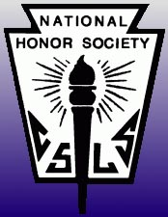
National Honor Society Tuesday, October 13, 2015
Loganville High School
Chapter Meeting Agenda

I. Roll Call

II. Creed:
“I pledge to maintain high scholastic standing,
To hold as fundamental and worthy
an untarnished character,
To endeavor intelligently and courageously
To be a leader,
And to give of myself freely in service of others.
In so doing, I shall prove myself worthy
Of a place in the National Honor Society.”

III. Dues
- $30

IV. Shirt Decisions
- Shirt color: burgundy
- Ink color: white
- Quote: “I never dreamed of success, I worked for it.” – Estée Lauder

V. Service Projects
- 2 projects per semester
- If you do not complete 2 this semester, you will have to complete 4 next semester.

VI. Service Project Opportunities
- FISH – 2 hours is one service project
- Check email regularly for service project updates

VII. Next Meeting
- Tuesday, November 10th
- We will be writing letters of gratitude to U.S. soldiers. Please come prepared (markers, etc.)
  - Flyer attached (also on website)

X. There is now an NHS page on Mrs. Halford’s class website
(www.mrshalford-classwebsite.weebly.com)

You must complete at least 2 service projects by the end of the semester!

